NO. 4

JOURNAL

of the

HOUSE OF REPRESENTATIVES

of the

STATE OF SOUTH CAROLINA

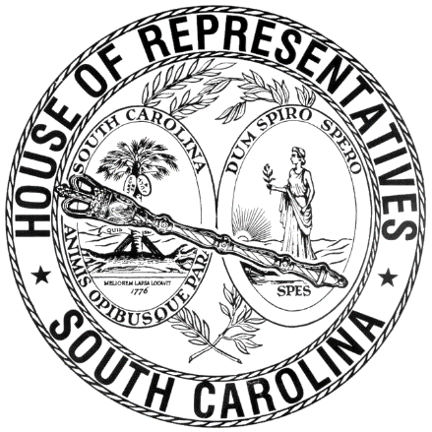

REGULAR SESSION BEGINNING TUESDAY, JANUARY 12, 2021
________

FRIDAY, JANUARY 14, 2022
(LOCAL SESSION)

Indicates Matter Stricken
Indicates New Matter

The House assembled at 10:00 a.m.
Deliberations were opened with prayer by Rev. Charles E. Seastrunk, Jr., as follows:

Our thought for today is from Isaiah 2:5: “O House of Jacob, come, let us walk in the light of the Lord!”
Let us pray. Loving and compassionate God, guide these women and men who You have called to represent the people of their county, town, and city. Grant them Your blessings as they do the work assigned to them. For those who guide and direct these, Your people, give them safety and refresh them for another week of service. Look in favor on our World, Nation, President, State, Governor, Speaker, Staff, and all who give of their time and efforts for this great cause. Bless and defend our men and women who protect us. Lord, in Your mercy, hear our prayers. Amen.

Pursuant to Rule 6.3, the House of Representatives was led in the Pledge of Allegiance to the Flag of the United States of America by the SPEAKER.

After corrections to the Journal of the proceedings of yesterday, the SPEAKER ordered it confirmed.

SENT TO THE SENATE
The following Bill was taken up, read the third time, and ordered sent to the Senate:

H. 4495 -- Reps. B. Newton, McGarry and Yow: A BILL TO AMEND SECTION 7-7-350, AS AMENDED, CODE OF LAWS OF SOUTH CAROLINA, 1976, RELATING TO THE DESIGNATION OF VOTING PRECINCTS IN LANCASTER COUNTY, SO AS TO REVISE THE NAMES OF FIVE PRECINCTS, AND TO UPDATE THE MAP NUMBER ON WHICH THE NAMES OF THESE PRECINCTS MAY BE FOUND AND MAINTAINED BY THE REVENUE AND FISCAL AFFAIRS OFFICE.

ADJOURNMENT
At 10:20 a.m. the House, in accordance with the ruling of the SPEAKER, adjourned to meet at 12:00 noon, Tuesday, January 18.
***

H. 4495 1

