NO. 49

JOURNAL

of the

HOUSE OF REPRESENTATIVES

of the

STATE OF SOUTH CAROLINA

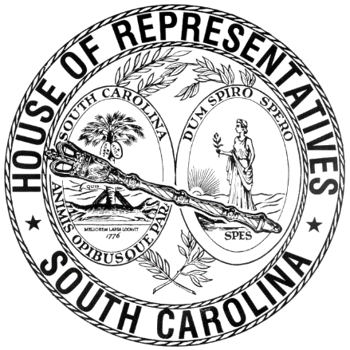

REGULAR SESSION BEGINNING TUESDAY, JANUARY 12, 2021
________

FRIDAY, APRIL 22, 2022
(LOCAL SESSION)

Indicates Matter Stricken
Indicates New Matter

The House assembled at 10:00 a.m.
Deliberations were opened with prayer by Rev. Charles E. Seastrunk, Jr., as follows:

Our thought for today is from Psalm 19:1: “The heavens declare the glory of God, and the sky proclaims its handiwork.”
Let us pray. We give You thanks Almighty God, that You restore us with Your caring ways. Refresh us as we go into the weekend. Keep us safe and in good health. Give us the confidence of faith, O Lord, that we may be so bold as to share Your love with others. Bless our defenders of freedom and first responders. Look in favor upon our World, Nation, President, State, Governor, Speaker, Staff, and all who contribute to this great cause. Protect us and Your people in Ukraine. Look in favor upon our men and women who suffer and sacrifice for our freedom. Lord, in Your mercy, hear our prayers. Amen.

After corrections to the Journal of the proceedings of yesterday, the SPEAKER ordered it confirmed.

STATEMENT FOR THE JOURNAL
Thursday, April 21, 2022
In a review of legislation filed during today’s session, I discovered my name was added to H. 5261 I request my name be removed from sponsorship.
Rep. Bill Taylor

SENT TO THE SENATE
The following Bill was taken up, read the third time, and ordered sent to the Senate:

H. 5182 -- Reps. Lucas, Fry, Hewitt, Bailey, Erickson, Dillard, Huggins, Wooten, Caskey, Ballentine, R. Williams and Jefferson: A BILL TO AMEND THE CODE OF LAWS OF SOUTH CAROLINA, 1976, TO ENACT THE "SOUTH CAROLINA OPIOID RECOVERY ACT" BY ADDING CHAPTER 50 TO TITLE 44 SO AS TO PROVIDE FOR PURPOSES OF THE ACT, PROVIDE DEFINITIONS, ESTABLISH THE SOUTH CAROLINA OPIOID RECOVERY FUND, ESTABLISH THE DISCRETIONARY SUBFUND, ESTABLISH THE GUARANTEED POLITICAL SUBDIVISION SUBFUND, ESTABLISH THE ADMINISTRATIVE SUBFUND, ESTABLISH THE SOUTH CAROLINA OPIOID RECOVERY FUND BOARD, PROVIDE THAT THE STATE FISCAL ACCOUNTABILITY AUTHORITY IS RESPONSIBLE FOR ADMINISTRATIVE OPERATIONS, PROVIDE FOR CERTAIN RESTRICTIONS ON BRINGING CERTAIN CLAIMS, AND TO PROVIDE THAT THIS ACT MUST BE LIBERALLY CONSTRUED.

ORDERED ENROLLED FOR RATIFICATION
The following Bill was read the third time, passed and, having received three readings in both Houses, it was ordered that the title of each be changed to that of an Act, and that they be enrolled for ratification:

S. 11 -- Senators Jackson, Shealy, Hutto, Cash and Malloy: A BILL TO AMEND THE CODE OF LAWS OF SOUTH CAROLINA, 1976, BY ADDING SECTION 8-11-150 SO AS TO PROVIDE TWELVE WEEKS OF PAID FAMILY LEAVE FOR STATE EMPLOYEES DUE TO THE BIRTH, ADOPTION, OR FOSTER CARE OF A SON OR DAUGHTER.

ADJOURNMENT
At 10:20 a.m. the House, in accordance with the ruling of the SPEAKER, adjourned to meet at 12:00 noon, Tuesday, April 26.
***

H. 5182 1

S. 11 2

