SENATE TO MEET AT 1:00 P.M. TODAY

**NO. 9**

**CALENDAR**

OF THE

**SENATE**

OF THE

**STATE OF SOUTH CAROLINA**

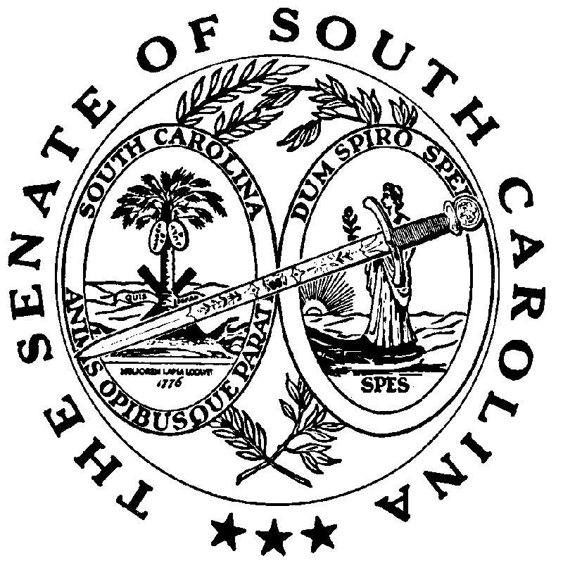

**REGULAR SESSION BEGINNING TUESDAY, JANUARY 14, 2025**

**_______________**

**WEDNESDAY, JANUARY 29, 2025**

**Wednesday, January 29, 2025**

JOINT ASSEMBLY

(Wednesday, January 29, 2025 at 7:00 P.M.)

H. 3660--Rep. G.M. Smith: A CONCURRENT RESOLUTION INVITING HIS EXCELLENCY, HENRY DARGAN MCMASTER, GOVERNOR OF THE STATE OF SOUTH CAROLINA, TO ADDRESS THE GENERAL ASSEMBLY IN JOINT SESSION AT 7:00 P.M. ON WEDNESDAY, JANUARY 29, 2025, IN THE CHAMBER OF THE SOUTH CAROLINA HOUSE OF REPRESENTATIVES.

(Adopted--January 15, 2025)

INVITATIONS

**Wednesday, January 29, 2025 – 8:00 - 10:00 a.m.**

Members, Breakfast, 112 Blatt Building, hosted by **AMIKIDS**

(Accepted-January 13, 2025)

**Wednesday, January 29, 2025 – 11:30 a.m. - 2:00 p.m.**

Members, Luncheon, 112 Blatt Building, hosted by the **SC ASSOCIATION FOR COMMUNITY ECONOMIC DEVELOPMENT**

(Accepted-January 13, 2025)

**Wednesday, January 29, 2025 – 12:00 - 2:00 p.m.**

Members, Luncheon, The Palmetto Club, hosted by the **SOUTH CAROLINA ASSOCIATION OF TECHNICAL COLLEGE COMMISSIONERS**

(Accepted-January 17, 2025)

**Wednesday, January 29, 2025 – 5:00 - 7:00 p.m.**

Members and Staff, Reception, Capital Center Atrium, 1201 Main Street, hosted by the **SOUTH CAROLINA BAR ASSOCIATION**

(Accepted-January 13, 2025)

**Thursday, January 30, 2025 – 8:00 - 10:00 a.m.**

Members and Staff, Breakfast, 112 Blatt Building, hosted by the **SOUTH CAROLINA** **FRATERNAL ORDER OF THE POLICE**

(Accepted-January 13, 2025)

**UNCONTESTED LOCAL**

SECOND READING BILLS

S. 213--Senator Turner: A BILL TO AMEND ACT 919 OF 1928, AS AMENDED, RELATING TO THE POWERS AND DUTIES OF THE GREENVILLE AIRPORT COMMISSION, SO AS TO INCREASE THE AUTHORIZED TOTAL INDEBTEDNESS TO TWENTY MILLION DOLLARS.

(Without reference--January 15, 2025)

S. 282--Senator Zell: A BILL TO PROVIDE THAT THE MEMBERS OF THE CLARENDON COUNTY AERONAUTICS COMMISSION SHALL BE APPOINTED BY THE GOVERNOR UPON THE RECOMMENDATION OF THE CLARENDON COUNTY LEGISLATIVE DELEGATION.

(Without reference--January 28, 2025)

MOTION PERIOD

INTERRUPTED DEBATE

(Debate was interrupted by adjournment on Tuesday, January 28, 2025)

S. 62--Senators Hembree, Rice and Grooms: A BILL TO AMEND THE SOUTH CAROLINA CODE OF LAWS BY AMENDING SECTION 59-8-110, RELATING TO DEFINITIONS, SO AS TO DEFINE NECESSARY TERMS; BY AMENDING SECTION 59-8-115, RELATING TO THE STANDARD APPLICATION PROCESS, SO AS TO PROVIDE REQUIREMENTS FOR STUDENTS AND SCHOOLS SEEKING TO PARTICIPATE IN THE PROGRAM; BY AMENDING SECTION 59-8-120, RELATING TO ADMINISTRATION OF FUND, SO AS TO PROVIDE FOR THE ADMINISTRATION OF THE K-12 EDUCATION LOTTERY SCHOLARSHIP; BY AMENDING SECTION 59-8-125, RELATING TO FUNDS TO CREATE, OVERSEE, AND THE ADMINISTER PROGRAM, SUSPENSION OF ACCOUNTS, UNUSED FUNDS, AND TERMINATION OF SCHOLARSHIPS, SO AS TO APPROPRIATE FUNDS FOR THE SCHOLARSHIP PROGRAM FROM THE SOUTH CAROLINA EDUCATION LOTTERY ACCOUNT; BY AMENDING SECTION 59-8-130, RELATING TO TERMINATION OF SCHOLARSHIP STUDENT’S PROGRAM; NOTIFICATION, SO AS TO MAKE CONFORMING CHANGES; BY AMENDING SECTION 59-8-135, RELATING TO LIMITATIONS ON SCHOLARSHIPS, SO AS TO PROVIDE LIMITATIONS ON THE NUMBER OF SCHOLARSHIPS THAT MAY BE AWARDED; BY AMENDING SECTION 59-8-140, RELATING TO THE APPLICATION APPROVAL PROCESS FOR EDUCATION SERVICE PROVIDERS, SO AS TO PROVIDE THAT AN EDUCATION SERVICE PROVIDER MUST CERTIFY ANNUALLY TO THE DEPARTMENT THAT IT MEETS ALL PROGRAM REQUIREMENTS; BY AMENDING SECTION 59-8-145, RELATING TO PROCEDURES TO INFORM STUDENTS AND THEIR PARENTS OF ELIGIBILITY AND APPROVED EDUCATION SERVICE PROVIDERS, SO AS TO MAKE CONFORMING CHANGES; BY AMENDING SECTION 59-8-150, RELATING TO REQUIREMENTS FOR EDUCATION SERVICE PROVIDERS, DEPARTMENT, AND EDUCATION OVERSIGHT COMMITTEE, SO AS TO PROVIDE THAT THE SURETY BOND IS REQUIRED OF EDUCATION SERVICE PROVIDERS WHO EXCEED FIFTY THOUSAND DOLLARS IN QUALIFYING EXPENSES AND TO MAKE CONFORMING CHANGES; BY AMENDING SECTION 59-8-160, RELATING TO THE K-12 EDUCATION LOTTERY SCHOLARSHIP REVIEW PANEL, SO AS TO PROVIDE FOR ITS COMPOSITION AND PURPOSES; BY AMENDING SECTION 59-8-165, RELATING TO STUDENT TRANSFER POLICY, SO AS TO CLARIFY STUDENT TRANSFER REQUIREMENTS; BY AMENDING SECTION 59-8-170, RELATING TO IMMEDIATE PARTICIPATION IN A SPORT BY A TRANSFER SCHOLARSHIP STUDENT, SO AS TO MAKE CONFORMING CHANGES ; AND BY AMENDING SECTION 59-150-350, RELATING TO THE EDUCATION LOTTERY ACCOUNT MANAGEMENT, SO AS TO MAKE CONFORMING CHANGES.

(Read the first time--January 14, 2025)

(Polled by Committee on Education--January 14, 2025)

(Favorable)

(Amended--January 16, 2025)

(Amended--January 28, 2025)

STATEWIDE SECOND READING BILLS

S. 89--Senator Young: A BILL TO AMEND THE SOUTH CAROLINA CODE OF LAWS BY AMENDING SECTION 25‑11‑100, RELATING TO SOUTH CAROLINA MILITARY BASE TASK FORCE, SO AS TO RENAME THE TASK FORCE THE SOUTH CAROLINA MILITARY AFFAIRS ADVISORY COUNCIL, TO REVISE THE COUNCIL’S MISSON, TO INCREASE THE MEMBERSHIP ON THE COUNCIL, TO MANDATE THAT THE COUNCIL MEETS AT LEAST ONE TIME EACH CALENDAR YEAR, AND TO MAKE CONFORMING CHANGES.

(Read the first time--January 14, 2025)

(Reported by Committee on Family and Veterans’ Services--January 28, 2025)

(Favorable)

S. 103--Senators Climer, Kimbrell, Verdin, Leber and Zell: A BILL TO AMEND THE SOUTH CAROLINA CODE OF LAWS BY AMENDING SECTION 47-17-510, RELATING TO THE PROHIBITION AGAINST MISLEADING OR DECEPTIVE PRACTICES, LABELING, OR MISREPRESENTING PRODUCT THAT IS CELL-CULTURED MEAT, SO AS TO DEFINE CELL-CULTIVATED FOOD PRODUCT AND REQUIRE THE ACCURATE LABELING OF CELL-CULTIVATED FOOD PRODUCT.

(Read the first time--January 14, 2025)

(Reported by Committee on Agriculture and Natural Resources--January 28, 2025)

(Favorable with amendments)

S. 218--Senator Young: A BILL TO AMEND THE SOUTH CAROLINA CODE OF LAWS BY ADDING SECTION 25‑11‑730 SO AS TO PROVIDE THAT THE DEPARTMENT OF VETERANS’ AFFAIRS SHALL ADOPT CRITERIA FOR ADMISSIONS TO AND DISCHARGES FROM SOUTH CAROLINA VETERANS’ HOMES.

(Read the first time--January 15, 2025)

(Reported by Committee on Family and Veterans’ Services--January 28, 2025)

(Favorable)

H. 3727--Rep. W. Newton: A BILL TO ADOPT REVISED CODE VOLUME 9 OF THE SOUTH CAROLINA CODE OF LAWS, TO THE EXTENT OF ITS CONTENTS, AS THE ONLY GENERAL PERMANENT STATUTORY LAW OF THE STATE AS OF JANUARY 1, 2025.

(Read the first time--January 22, 2025)

(Recalled from Committee on Judiciary--January 28, 2025)

SENATE RESOLUTION

S. 195--Senators Campsen, Davis and Matthews: A SENATE RESOLUTION TO DECLARE THE MONTH OF MARCH 2025 AS “THE CELEBRATION OF THE BICENTENNIAL OF THE MARQUIS DE LAFAYETTE’S VISIT DURING HIS FAREWELL TOUR OF THE NATION IN 1825” IN SOUTH CAROLINA.

(Introduced--January 14, 2025)

(Reported by Committee on Family and Veterans’ Services--January 28, 2025)

(Favorable)

CONCURRENT RESOLUTIONS

S. 193--Senators Reichenbach, Sabb and Williams: A CONCURRENT RESOLUTION TO REQUEST THE DEPARTMENT OF TRANSPORTATION NAME THE PORTION OF CASHUA DRIVE IN THE CITY OF FLORENCE IN FLORENCE COUNTY FROM ITS INTERSECTION WITH SECOND LOOP ROAD TO ITS INTERSECTION WITH UNITED STATES HIGHWAY 76 “CURTIS KERSHAW SUMMERFORD MEMORIAL HIGHWAY” AND ERECT APPROPRIATE SIGNS OR MARKERS ALONG THIS PORTION OF HIGHWAY CONTAINING THESE WORDS.

(Introduced--January 14, 2025)

(Recalled from Committee on Transportation--January 28, 2025)

S. 224--Senator Tedder: A CONCURRENT RESOLUTION TO RECOGNIZE JANUARY 2025 AS “MENTORING MONTH” IN SOUTH CAROLINA.

(Introduced--January 15, 2025)

(Reported by Committee on Family and Veterans’ Services--January 28, 2025)

(Favorable)

**SENATE CALENDAR INDEX**

**S. 62 3**

**S. 89 4**

**S. 103 5**

**S. 193 6**

**S. 195 6**

**S. 213 2**

**S. 218 5**

**S. 224 6**

**S. 282 2**

**H. 3660 1**

**H. 3727 5**